LEXINGTON Single but Joint Together

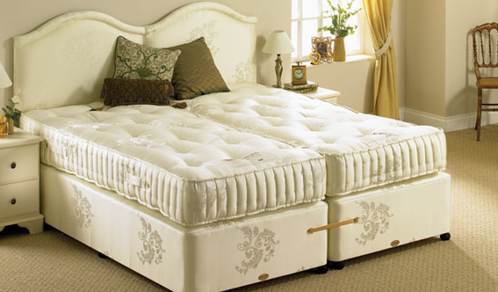

|  |
| --- |
| **DESCRIPTION** |
| LEXINGTON introduces stylish single bed with cream form touch the single set of bed is sure to create the perfect look in any home. The rich wood of the bed pairs perfectly with many different styles of decor. Perfect for your bedrooms or just an extra help in your house. The two beds are separated yet they are so close because the designed in such which seems that they are separated but actually they are build and acts as one just separated by two spring mattress. |

|  |  |  |
| --- | --- | --- |
| **Price** | **1050$** | |
| **Dimensions** | **H** x **W** x **L** | **30in x 65in x 75in** |
| **Features** | **veneer wood with water resistance nano technology plus heat resisted fiber mass which makes it perfect near beach areas** | |
| **Finished** | **Bold White Substitute** | |
| **Available in** | **Cream and Off White** | |